Sgoil-àraich Stafainn – Staffin Nursery



HANDBOOK

Session 2025-2026

Bun sgoil Stafainn Stenscholl Staffin Portree Isle Of Skye IV519JS
Tel: 01470 562273.
Email: staffin.primary@highland.gov.uk

Mrs C MacFarlane - Ceannard/Head Teacher

* Whilst information in this handbook is considered to be true and correct at the date of publication – February, 2025, changes in circumstances after the time of publication may impact on the accuracy of the information. *

RO-RADH – INTRODUCTION

Sgoil-àraich Stafainn – Staffin Nursery

Stenscholl
Staffin
Portree
Isle of Skye
IV51 9JS
Tel: 01470 562273
A LETTER FROM THE HEAD TEACHER – LITIR BHON CHEANNARD

We look forward to welcoming you and your child/children to Sgoil-àraich Stafainn/ Staffin Nursery and hope you all enjoy being part of our school community.

We very much hope that you and your child will enjoy your time at Sgoil-àraich.

Your child is at a very crucial stage in his/her development. As it is now accepted that children learn more rapidly in the first seven years of life than at any other time. Therefore, it is really important that the children are given every opportunity to fulfil their potential. As a parent you play a vitally important part in the process. As they enter their nursery school they come with a significant background of learning experiences within their family and their friends, neighbours, relatives, and others in the community. Staff in the nursery will want to work in partnership with parents in developing their child's learning. We will promote this partnership by learning about, valuing and building upon the child's learning experiences before and during their pre-school year, leaving them confident, eager and enthusiastic learners who are looking forward to starting school. As staff at Sgoil-àraich we will, therefore, always try to help with any enquiries you have with regard to your child. We in the Sgoil-àraich hope to play our part by treating your child as an individual and offering him/her a variety of experiences and activities which are designed to further the development process.

We hope that your child will find that learning can be an enjoyable and worthwhile process.

This handbook is intended to give you information about the Sgoil-àraich but please feel free to get in contact with us if there is anything about which you are uncertain.

Dùrachdan,
Mrs MacFarlane

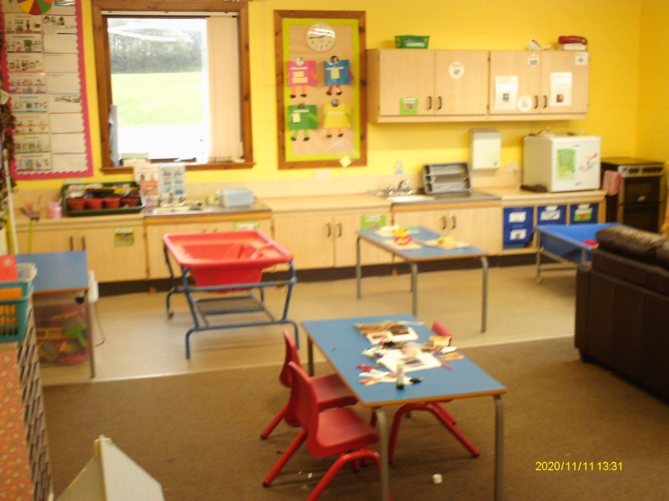
Whilst the information in this handbook is considered to be true and correct at the date of publication, changes in circumstances after the time of publication may impact on the accuracy of the information. The following information has been compiled for session 2025-2026. Any changes which occur will be notified in the school newsletters which are sent out regularly during the school year. Parents wishing an appointment with the Head Teacher or a member of staff are asked, if possible, to telephone in advance. Visits are best arranged for a time after 3.15 p.m.

FIOSRACHADH-SGOILE - SCHOOL INFORMATION
Address : Staffin Nursery,
: Stenscholl,
: Staffin.
: IV51 9JS.
School Telephone No. : 01470 562273.
Email : Staffin.primary@highland.gov.uk

Nursery Hours : Monday, Tuesday, Wednesday & Thursday 8.30am – 3.30pm
: Friday 8.30am-12.30pm

Staff Members : Mrs Chrisma MacFarlane - Head Teacher

Gaelic Nursery : Mrs Anna McDonnell - Early Years Practitioner
: Miss Christina MacDonald - Early Years Practitioner

School Secretary : Mrs Jackie Newbold

Why Choose a Gaelic Medium Nursery?

Research has shown that bilingualism is beneficial for children’s development and their future.

Conference video still 1Professor Antonella Sorace is Professor of Developmental Linguistics at the University of Edinburgh and is also the Director of Bilingualism Matters, a project which helps more children benefit from bilingualism. Establishing branches of Bilingualism Matters helps parents to make informed choices about the benefits of bilingual education. She believes that in order to bridge the gap it is essential that the correct information about the benefits of bilingualism is disseminated among families, teachers, health professional and policy makers to enable more and more children to grow up bilingual.

Bilingual children understand at an earlier age that other people may have a different perspective from their own so they have awareness of other people’s point of view. This advantage comes from children’s constant experience of choosing a language on the basis of the person they talk to. Many studies (including our own research) have found that child second language learners can also benefit from the cognitive advantages of bilingualism. People who grow up with more than one language have a range of mental benefits that make them better at learning and more effective at dealing with complex situations. Exposure to another language in the primary school years is more likely to lead to bilingualism than in late adolescent/adult years so the best ‘window of opportunity’ for becoming fully bilingual is early childhood

http://www.bilingualism-matters.org.uk/

Gaelic Education | Comann Nam Parant

Bilingualism gives children a lot more than two languages:-

Social advantages
- access to two cultures

- more tolerance towards/interest in other cultures

- easier to travel, find a job later on, etc.

Linguistic advantages
- early awareness of sounds, words, sentences

- enhanced language learning abilities

- earlier reading

Cognitive advantages
- mental benefits: how children think and use their brain in many situations.

Therefore, learning to speak Gaelic is a wonderful opportunity to provide children with the benefits of bilingualism.

ACHEIVEMENT/ SOIRBHEACHAIS
Pupil achievement is marked in a number of ways.

At our regular whole school assemblies award certificates and stickers are given to pupils.
Wider achievements are celebrated in the nursery and on nursery/school displays, in school newsletters and in local newspapers. The nursery also use stickers, certificates, notes home and stampers to show something has been achieved.

ADMINISTRATION OF MEDICATIONS/ A’ TOIRT SEACHAD LEIGHEIS
Some children may require taking medication in order that they can continue to attend school.
Staff will only administer medication when there is clear written guidance from the parents. Copies of the required Forms 1a and 1b can be obtained from the school office.
Parents are kindly requested to note that:
- A child may only take prescribed and labelled medication once the parent/guardian has completed the administration of medication form
- Parents should deliver the medication to school and only medication supplied by the parent/guardian will be administered to a child
- Pupils will take medication under adult supervision
- Non prescribed medication should be administered at home

Please note that it is a parent/carers responsibility to ensure that any medication including EpiPens and inhalers are within their use-by-date and stored in school with a signed consent form.

Aims / Amasan

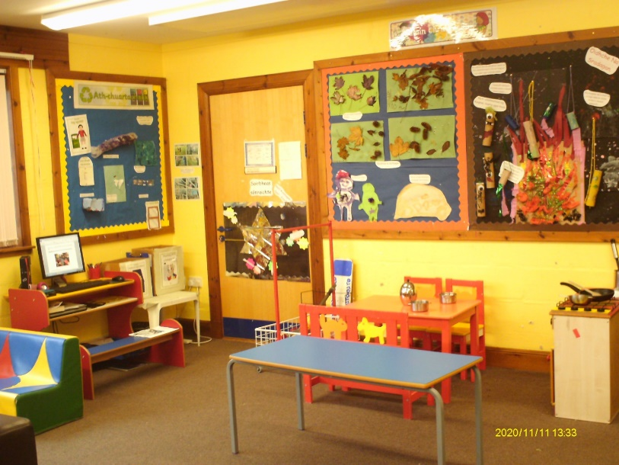

Sgoil-àraich Aims – We would Like:

To work together and learn together.
To make lots of friends and play together.
To be the best we can be and never give up.
To use and be part of our community.
To help everyone to give it a go!

ATTENDANCE/ FRITHEALADH
It is important that you try to be as punctual as possible, both in delivering and collecting your child, as the Sgoil-àraich it would be unfortunate if the children missed an important part of their session. A good attendance is paramount in supporting your child to reach his or her full potential
If a child can’t attend nursery, a parent or guardian should phone the school on the first day of absence on 01470 562 273. If a child falls ill during the day, parents are contacted for them to collect their child, therefore it is essential that we have up to date daytime contact numbers and emergency contact numbers for all pupils.
Your child should not attend nursery (even if he/she wants to come) for the statutory 48 hours following sickness and diarrhoea.
CHILD PROTECTION POLICY /POILEASAIDH DÌON CHLIONNE
From time-to-time incidents can occur within the school setting which cause concern and could indicate that a child is suffering from some form of abuse. In terms of Highland Child Protection Committee Inter-Agency Protection Guidelines, Education Service staff must report such incidents to Social Work Services which can lead to a joint Social Work/Police investigation.

All agencies involved in Child Protection are obliged to make the welfare of the children their paramount consideration and this will be priority for Education Service Staff. More information about Child Protection Procedures within Highland can be obtained from the Child Protection Development Officer, Highland Child Protection Committee, Kinmylies Building, Leachkin Road, Inverness, IV3 8NN-Telephone 01463 703483-Fax 01463 7213237 or www.forhighlandschildren.org

CLOTHING/ AODACH

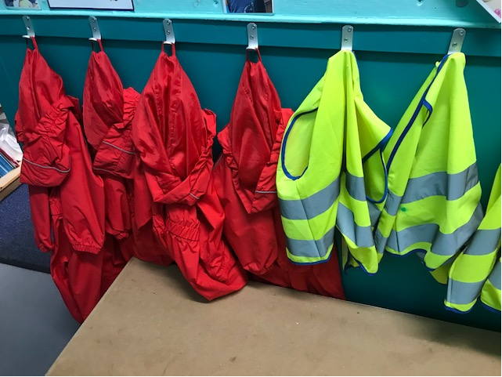

All children must bring a pair of suitable indoor shoes. It would be much appreciated if the shoes are easy to get on and off. Please make sure that all the children’s shoes and clothes are labelled clearly and that they are suitable for messy play. A change of clothing is helpful - this can be brought in daily or left at the Nursery. We have waterproof suits which we use for outdoor play and some wellies which your child can use. It is helpful for your child to have their own wellies when the weather is wet. Hats and gloves are particularly necessary during the colder months.

It often causes great concern to parents if their child is not toilet trained before starting nursery but no child is excluded because they are not toilet trained. Staff will, with your permission, change your child into either a nappy (please provide necessary supplies) or dry clothing. Staff follow the Highland Council intimate care policy and will always inform you when they have changed your child for any reason.

COLLECTING YOUR CHILD/ A’ TOGAIL DO PHÀISD
All children must be brought to the Sgoil-àraich and collected by an adult known to the child and staff. We ask that you sign your child in and out. Please contact the school if your child is to be collected by someone unknown to the staff or if the person collecting your child is not the one your child is expecting.

COMMENTS & COMPLAINTS/ BEACHDAN & GEARAIN
We always welcome comments and suggestions, and we have a Suggestions Box near the Parent Board. If you have any matter you wish to discuss please arrange an appointment with the nursery staff or the Head Teacher.

Failing a satisfactory conclusion to this complaint, the Care Inspectorate can be contacted at
the following address:

The Care Inspectorate (Headquarters)
Compass House
11 Riverside Drive,
DUNDEE
DD1 4NY
Tel: 01382 207100
Complaints: 0845 6030890

The Care Inspectorate (Local address)
1st Floor
Castle House
Fairways Business Park
INVERNESS
IV26AA
Tel: 01463 227630

COMMUNICATION WITH PARENTS/ CONNALTRADH RI PÀRANTAN
The Nursery aims to communicate with parents regularly through a number of ways – Stay and Play sessions, discussion of profiles, school meetings and events, e-mails, phone calls, letters, newsletters and Google Classroom posts.

We often seek parents’ views on matters through questionnaires, information evenings and through discussions.

CURRICULUM / CLÀR-OIDEACHAIDH
Few tasks are more important than promoting learning for children in their early years. Children who begin their education in a supportive and challenging environment are likely to become confident and successful learners.

We follow the Care Inspectorate Health and Social Care Standards, Education Scotland: How Good is Our Early Learning Centre? Document, Building the Ambition and Curriculum for Excellence to ensure a coherent and progressive approach to teaching and learning in all areas of the curriculum, encouraging all children to become:
- Successful learners
- Confident Individuals
- Responsible Citizens
- Effective Contributors

Play is the means by which your child will cover all these aspects.

So why play?

Play provides opportunities for children to:

- make sense of real-life situations
- develop awareness of themselves and others
- explore, investigate and experiment
- be actively involved in learning
- draw and test their conclusions
- develop self-confidence
- express their ideas and feelings in many different ways
- inhabit imagined situations
- act out and come to terms with experiences at home or with friends
- be solitary, quiet and reflective
- collaborate with others
- take the initiative on their own terms
- develop relationships
- practice skills
- consolidate previous learning
- be challenged in new learning

Activities offered to the children range from:
- Sand and water play
- Baking
- Play dough/Clay/Soft modelling material
- Painting
- Junk modelling
- Gluing/Collage
- Jigsaws
- Tracing/Drawing and other pre-writing activities
- Board games
- Construction toys, e.g. duplo, moblio, building blocks etc.
- Imaginative play, e.g. the home corner, post office, cafe, etc.
- Outdoor activities
- Story/Rhymes
- Musical activities
- Hall time - PE games, riding trikes and scooters

The curriculum in the Sgoil-àraich is based on Curriculum for Excellence and the staff implement this in their planning. They take account of the children’s current interests, their age, stage of development and their own individual needs. Some of the activities will be planned around a topic, with the children leading the learning. This will be recorded in a floor book. Each topic will incorporate activities related to the nursery curriculum. We appreciate any parental input/expertise to topics explored.

The Sgoil-àraich and outdoor area are well resourced with lots of open-ended ‘loose parts’ materials that the children can play with and be creative. Opportunities for using their imagination, problem-solving and being curious are designed by the staff who give the children activities and resources that provoke investigation.

The children progress at their own individual rate. The staff record ‘observations’ on children regularly and throughout the year we build up a profile of each child. which is contained in their ‘My learning Journey’ folder. We will interact with the children to identify their progress and then share observations and targets with parents by profiles, displays on the Parents' Notice board, the running of parent workshops on various aspects of a child's development and periodic news-sheets. We will plan, interact, record, report on and evaluate learning and teaching. Regular ’Stay and Play’ sessions are a good opportunity for you to view the children’s work and comment on the profiles and current floor book.

Being outdoors is a big part of our curriculum and the children are given ample opportunities to play outdoors every day, in mainly undirected play. They learn by investigating the local environment in all weathers and become increasingly independent when learning how to care for themselves, putting on their jacket and shoes and following good hygiene routines.

PHOTOGRAPHS
We are required to ask for parental permission to take and display photographs of the children. In a play-based curriculum, photographs provide good evidence of work done. We like to use pictures of the children to show the work they have been doing and like to display them on the walls of the Sgoil-àraich , to use them as part of the children’s own records , our Facebook page and in the production of our school newsletter which is circulated to the parents of children in the school.

We do not display any photos of your child over the internet without expressed parental permission. You will receive a permission slip at the start of the school term.

Cànan/ Communicating and Language
The development of children’s language skills in both Gaelic and English is central to their abilities to communicate with each other, to understand ideas and to explore and refine their thoughts.

Leughadh/ Reading
We aim to encourage your child to develop an enthusiasm for stories and books through hearing stories and rhymes, sharing books and encouraging him/her to re-tell favourite stories. Pre-reading skills will also be developed through matching and memory games, jigsaws and other play activities

Sgrìobhadh/ Writing
We aim to provide your child with opportunities to experiment with their own drawings and “mark making” in role-play situations. We also aim to develop good hand–eye co-ordination through gluing, cutting, threading beads and other similar tasks.

Èisteachd agus Labhairt/ Listening and Talking
We aim to provide a variety of experiences to develop your child’s listening skills. We will encourage your child to listen to stories, rhymes, songs and music, as well as listening for instructions and information in Gaelic. Social interaction, games and play activities will also provide opportunities for listening.

Measadh agus Aithisgean/ Evaluation and profiles
Taking a Sgoil-àraich profile home comes at the end of a long process which begins when your child starts Sgoil-àraich. This profile will be sent home to you when your child is in their pre-school year, towards the end of the summer term.

A’ gluasad dhan Sgoil/ Moving to Primary School
The management of effective transitions from Sgoil-àraich to Primary 1 will involve Sgoil-àraich and Primary staff visiting each other and sharing ideas about their practice, curriculum guidelines and the experience children will have within each setting (see Transitions and Admissions Policy). A careful assessment and review of each child’s learning over the early weeks will take place within the new setting. During the induction week, the children from Sgoil-àraich will attend at their normal time but will spend that time in the infant classroom instead of the nursery classroom.

EARLY CLOSURE OF SCHOOL/ A’ DÙNADH TRATH
If the nursery has to close early for any reason, all parents will be informed by phone. Parents should also supply the school with an alternative number. Parents who are not normally at home during nursery hours, are asked to supply a work contact number also. If parents cannot be contacted and there is no-one available at the emergency contact number, children will have to remain in nursery until collected by a parent.

It is vitally important that the emergency contacts for each child are kept up to date in the event of a child having to be sent home due to illness or accident in nursery or nursery closure. The nursery will request updated information at the beginning of every school session and may ask that you check details again during terms 2 & 3 when winter weather can cause school closures.

ENROLMENT/ A’ TÒISEACHADH SAN SGOIL
Enrolment of new children to nursery will be advertised in advance through the school Facebook page.

Parents who are considering enrolling their children are most welcome to visit the nursery to meet the Head Teacher and tour the school. An appointment can be arranged by telephoning the school.

Online enrolment forms can be found at,

https://www.highland.gov.uk/enrol

Some parents may wish to share provision with another setting. In this case the staff in the two settings will share information but your permission will be sought for this.

EVENTS/ TACHARTASAN
Our nursery organise events to celebrate events such as World Poetry Day, Numeracy Week, World Book Day and Remembrance Day. We try to involve the local community in these events, wherever possible.

How can you help?/ Cuideachadh

The answer lies in most of the activities you probably regard as ordinary

- read to your child often
- teach them nursery rhymes
- talk to them,
- encourage them to talk to you
- encourage them to ask questions

Please be assured we promote a parental partnership and strive to maintain an open door policy where parental views, contributions, consultation and even complaints are welcome. In the event of a complaint, please contact Mrs MacFarlane.

Care Inspectorate
Parents/Carers are also able to contact the Care Inspectorate directly with a complaint, if they so wish.
The local address and telephone number is Care Inspectorate, 1st Floor, Castle House, Fairways Business Park, Inverness, IV2 6AA Telephone 01463 227630. The Sgoil-àraich is inspected by the Care Inspectorate. Copies of their reports are available.

ILLNESS/ TINNEAS
If your child becomes ill, or has an accident whilst attending Sgoil-àraich we will contact you by telephone and you will receive an accident report. If there is no reply we will ring your emergency contact number.

We ask you not to bring into the nursery any child who has been vomiting or had diarrhoea until at least 48 hours has elapsed since the last attack.

If your child requires medication during the nursery session written parental permission is required to enable a member of staff to assist your child.

GIRFEC /Getting it Right For Every Child
Although your child attends nursery the Health Visitor is his/her named person. The Health Visitor should visit the Nursery termly. Information regarding child development is shared between staff through professional dialogue. If you do not wish information to be shared please contact the staff of Sgoil-àraich or the Health Visitor.

The early years of a child’s life consists of rapid growth and development and as a nursery staff we use the SHANARRI Wellbeing indicators for assessing children’s wellbeing.
- SAFE: Provide a safe and stimulating environment in which the child can feel happy and secure.
- HEALTHY: Promote the welfare of children. Encourage them to have routines.
- ACHIEVING: Create opportunities for play. Help children to talk about their learning and make personal targets for themselves. Help them to develop in emerging literacy and numeracy particularly.
- NURTURE: Nurture them by encouraging positive attitudes to self and others and develop confidence and self-esteem. Give them support. Show them positivity.
- ACTIVE: Provide opportunities to stimulate interest and imagination. Encourage lots of active activity: indoors and outdoors.
- RESPECTED: Able to make choices about their activities and needs. Encourage them to become independent.
- RESPONSIBLE: Encourage children to explore, appreciate and respect their environment. Learn about caring for their friends and understanding rules.
- INCLUDED: Extend the children’s abilities to communicate ideas and feelings in a variety of ways. Encourage them to make friends and build friendship groups.
We have a SHANNARI display in our Sgoil-àraich which records what we have done to cover the SHANARRI indicators and this will go into a floor book. Please have a look at this.

FOOD/ BIADH
Snack is an important part of Sgoil-àraich.

The children will be given a snack every morning. The main purpose of this activity is to develop a range of social skills associated with eating as well as Gaelic language practice. We use this opportunity to introduce a variety of different foods, and to encourage the children to eat healthily. An afternoon snack is also optional for children to partake in. The snack menus are displayed on the parents’ noticeboard.
Children are also provided with a 2-course lunch. Menus are sent home a week in advance for parents to complete with their child.

If your child suffers from allergies or has any other dietary requirements, please complete a special diet request form.

https://www.highland.gov.uk/downloads/file/65/special_diet_request_form

As part of our Health and Safety policy home-prepared food will not be eaten in nursery e.g. parties - however if a parent wishes to provide food on such an occasion, food brought from a reputable shop will be acceptable. Staff in the Sgoil-àraich do make an effort to mark important occasions such as birthdays by baking a cake.

The children help set the table and are encouraged to prepare much of the snack themselves under adult supervision.

POLICIES/ POLASAIDHEAN

All of the Sgoil-àraich policies are available to view in the nursery.

VISITS/ TURASAN
We believe that taking the children out on a variety of visits is a very important aspect of their education. At the beginning of the session we will ask you to sign a consent form to cover all regular visits. We will also ask you to sign a consent form for individual visits. On some occasions we may request extra help from parents to assist by accompanying us on the visit and/or helping with transport. Please ensure that you are covered by your car insurance and that you have an up to date disclosure check. Forms are available from the school office.

VACCINATIONS/ BANNACHDAICH

Children receiving out-of-home care, including at nursery and playgroup, have more opportunities to come into contact with infections, so it is especially important to make sure that that they have all the vaccinations due.
It is never too late to have your child immunised. If they have missed one, you don’t have to start the course from the beginning again.

Contact your health visitor/G.P. for further advice.

Getting it right for every child

Working together: Statement for parents

All pre-school education centres work closely with NHS Highland and other agencies so that the resources and information we have will bring the most benefit to families. The aim is to ensure we have the right services for your child at the right time.

Early Education services and NHS Highland collaborate to plan services and offer interventions, such as the Childsmile Oral Health Programme and the Pre-school Vision Screening Programme. To assist the administration of these programmes, we confirm your child’s name, date of birth and address to NHS Highland.

We have a Link Health Visitor, who visits the centre at least once a term. Their main role is to offer advice on children’s health and development. They will also liaise with your own Family Health Visitor if necessary.

Our centre’s Link Health Visitor is: Fiona Fletcher

Tel. No. (01478) 614885
If your child would benefit from help from other agencies, you will be asked for permission so that relevant information can be shared. This enables staff to get a rounded picture of your child and means you won’t keep being asked for the same information by different people. If your child’s immediate safety or welfare is at risk, information may legally be shared without your consent.

